Assignment 2

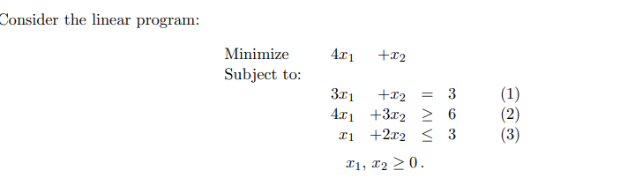

1. Find the optimal solution of the problem by applying Big M-method.
2. Solve the given problem graphically